**Project plan & Design Comps**

**Part 1: Project Plan & Design Comps**

* **Project Plan**

1. **Project Overview**

In recent years, the development of e-commerce websites in the world is in full swing. People can buy the goods they want without leaving home. Amazon in the US is a case of successful e-commerce websites. In order to learn website development technology and e-commerce marketing model. After experiencing this course, I decided to develop a bakery website.

Next, I will give a clear definition of this project, including purpose, goals, requirements, etc.

* 1. **Purpose**

Through the development of the bakery website, I can learn the relevant development technology and understand the preface technology in this respect, which is important for my academic and future career development. In addition, through actual hands-on development, I can also test my learning results. This process must be full of difficulties. When encountering difficulties, we must rise to the difficulties and improve our abilities in the constant setbacks.

* 1. **Goals**

The preliminary goals of the bakery site includes:

* Every page can interact responsively, has web form functionalities.
* Verify the format of special information in the form, such as the format of email and phone number.
* Display product details and business information.
* The website has beautiful design and strong portability to equipment. For example, it can be displayed well on PC, Pad ,Phone.

**1.3 Requirements**

The functional requirements of my intented site includes:

* Enable to view product details and purchase products.
* The search page displays a list of popular products.
* Enable to view merchant information and contact with merchants.
* Submit the customer information form and display a message on a following page showing the information that was sent.

1. **Key technologies**
   1. **Front-end development**

Front-end development refers to the use of Html, Css, JavaScript and various derived technologies, frameworks, and solutions to present to users through the creation of front-end interfaces such as Web pages or apps. Early websites were mainly static websites, with pictures and texts as the mainstay, and users mainly browsed websites. With the development of Internet technology and the application of Html5 and Css3, modern web pages are more beautiful, interactive and more powerful.

* 1. **Html**

HTML is the skeleton of web pages, a hypertext tag language, and a markup language designed for "web page creation and other information that can be seen in web browsers". HTML is used to construct headlines, paragraphs, images, multimedia and other information, and can also be used to describe the appearance and semantics of documents to a certain extent.

* 1. **CSS**

CSS is a computer language used to express file styles (such as HTML or XML). CSS refers to cascading style sheets, which define how HTML elements are displayed and are usually stored in style sheets. Style seems to solve the problem of separation of content and presentation. HTML tags were originally designed to define the content of documents.

* 1. **JavaScript**

JavaScript is a literal scripting language, weakly dynamic type, prototype-based language and built-in support type. Its interpreter is called the JavaScript engine, which is a part of the browser. It is widely used in the scripting language of the client. It was first used on HTML web pages to add dynamic functions to HTML web pages. By writing a simple JavaScript program, you can show and hide the content; by writing a more complex program, you can load data and dynamically update the page**.**

1. **Site Structure Design**

This website is developed based on static web page technology, and mainly uses HTMl5 and CSS3 technology to beautify the page in the page display. For the dynamic display of web pages, Bootstrap framework and some open source plug-ins are applied. For example, the display of the carousel, the effect of switching the navigation bar. For logic control, JavaScript and JQuery technology are mainly applied. For instance, Verification of the form data format, when the mouse is removed from the label for verification, the data of the static page is transmitted through the URL. Get the URL string and intercept the required parameter information. The use of JQuery technology greatly simplifies the coding of Js.

1. **Project Schedule**

week 1 — week 3 : Demand analysis and selection of proposed technologies.

week 4 — week 6 : Learn the web development technique of your choice.

week 7 — week 9 : Website design and development.

week10 — now Usability test and update.

* **Design Compos**

In this part, I have designed two basic pages, which are the Homepage of the website and the store owner information display page About As. Figure 1 and Figure 2 show the two developed pages. The style of the other pages of the website will also refer to them.

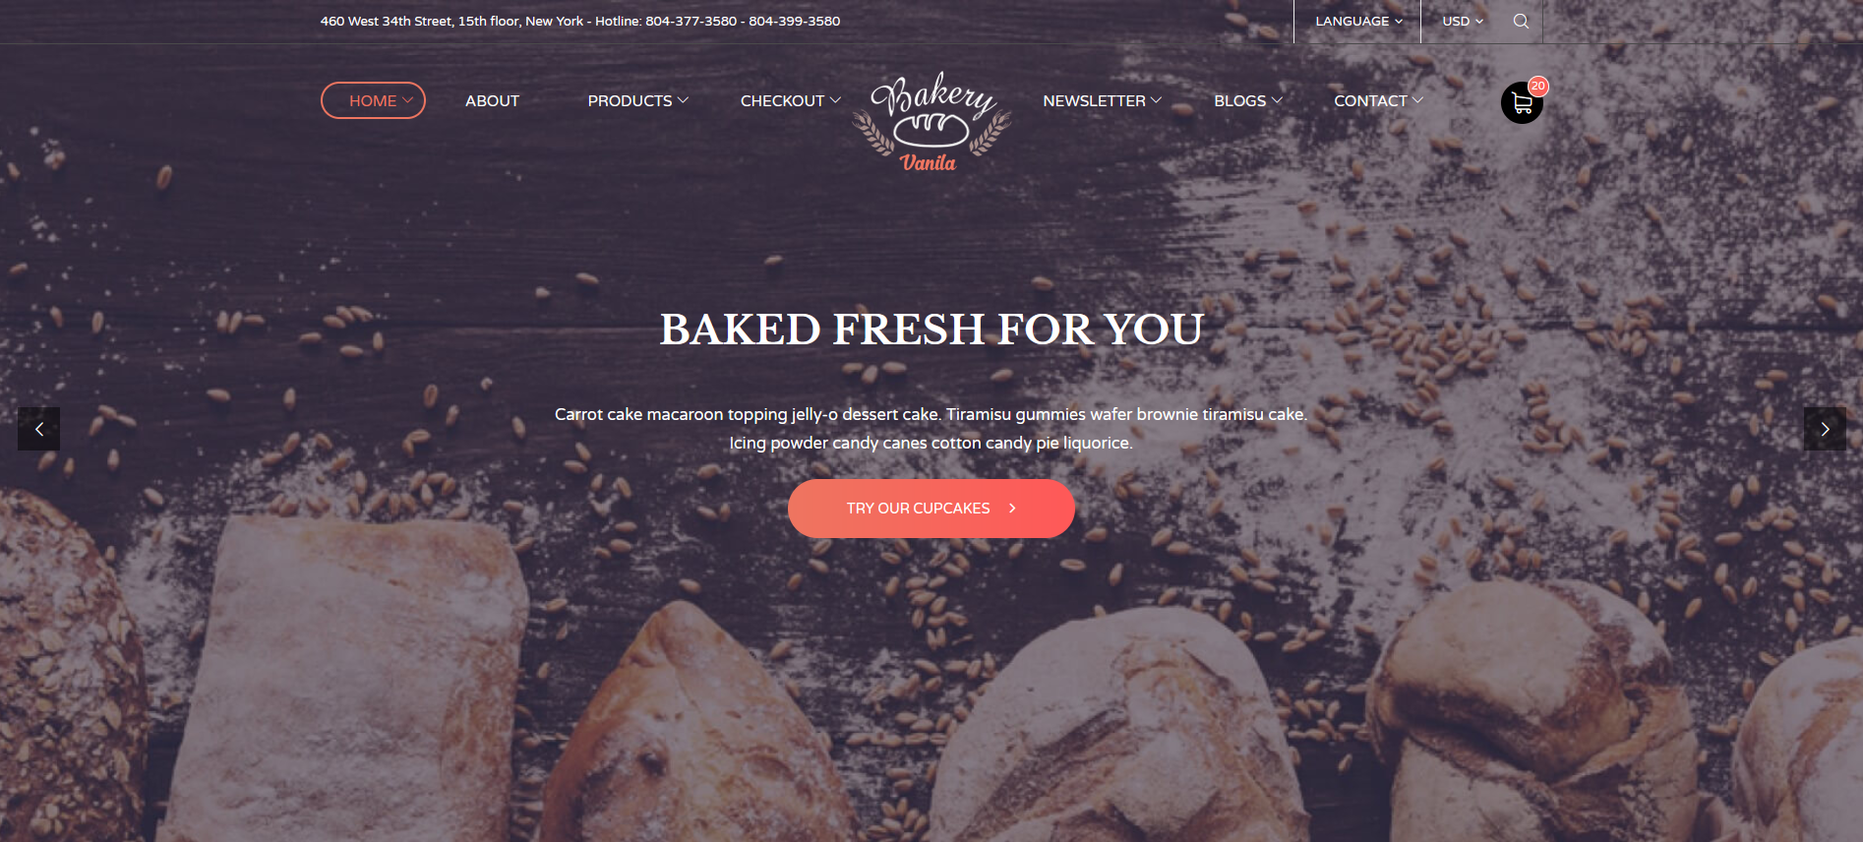

Figure 1 HomePage of bakery site

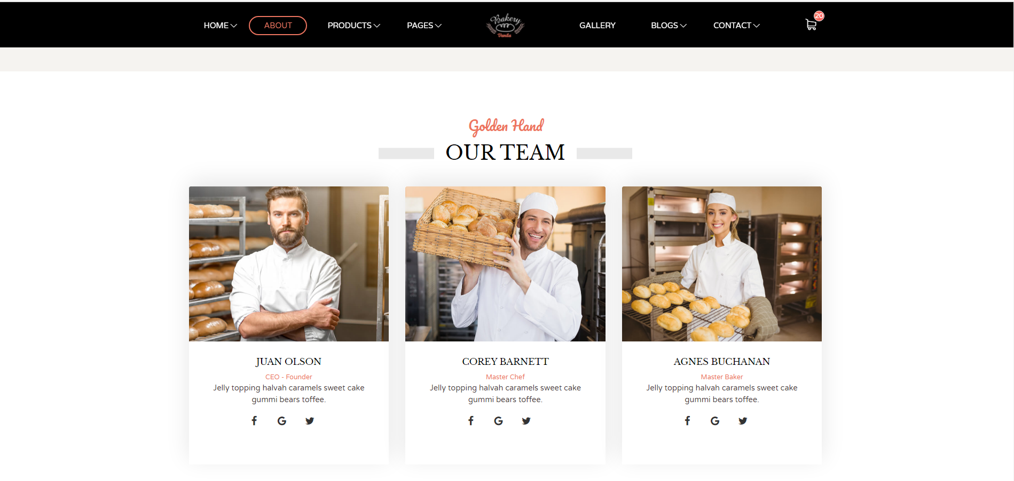

Figure 2 About us of bakery site

**Part 2: Design Rationalisation**

In the Figure 1, Three colors are mainly used in the homepage, which are white(#ffffff), orange(#ee7560) and black(#282c2f). The background is a picture of making bread with chocolate tones. There are three styles of fonts including font-family: "Varela Round", sans-serif; " font family: "Libre Baskerville", serif. The font size is set to font-weight: 700; font-size: 23px; font-weight: 400; font-size: 8px. The main page also includes a navigation bar and some web page information to help customers understand the bakery store.

In the Figure 2, Pages’ colors also are same as Figure 1, which are white(#ffffff), orange(#ee7560) and black(#282c2f). But, in order to increase the beauty of the page, I added new fonts, such as font-family: "Pacifico", cursive and font-size is 24px. On this page, not only has a navigation bar, but also displays information about store staff, including their names, photos, positions, etc.

These two pages have been developed, are very greater, the subsequent need to change, increase the functionality of the site, will be more content to show, such as: bread believe information, the information of sales promotion, stores detailed intro-

duction and so on, also for style display problems need to be adjusted, step in place to ensure that beautiful sex and practicability of the site.

**Part 3: Usability Test Plan**

* **Document Overview**

This document describes a test plan for conducting a usability test during the development of bakery site. The goals of usability testing include establishing a baseline of user performance, establishing and validating user performance measures, and identifying potential design concerns to be addressed in order to improve the efficiency, productivity, and end-user satisfaction.

The usability test objectives are:

* To determine design inconsistencies and usability problem areas within the user interface and content areas. Potential sources of error may include:

1. Navigation errors – failure to locate functions, excessive keystrokes to complete a function, failure to follow recommended screen flow.
2. Presentation errors – failure to locate and properly act upon desired information in screens, selection errors due to labeling ambiguities.
3. Control usage problems – improper toolbar or entry field usage.

* Exercise the application or web site under controlled test conditions with representative users. Data will be used to access whether usability goals regarding an effective, efficient, and well-received user interface have been achieved.
* Establish baseline user performance and user-satisfaction levels of the user interface for future usability evaluations.
* **Goal of the site**
* Every page can interact responsively, has web form functionalities.
* Verify the format of special information in the form, such as the format of email and phone number.
* Display product details and business information.
* **User testing detail**

User information is shown in Table 1

Table 1 User information

|  |  |  |  |  |  |
| --- | --- | --- | --- | --- | --- |
| **User** | **Name** | **Phone** | **Age** | **employment** | **interests** |
| 1 | Marry | 7433232323 | 23 | Student | Tasting food |
| 2 | Jorn | 7435677763 | 21 | Waiter | Play basketball |

* **Pre-test questions**
* Would you use it if there was a bakery website?
* What do you expect from the bakery website?
* Are you willing to take a website test?
* **Test tasks and schedule**
* Provide test laboratory site and equipment for testing, and inform the tester of all matters needing attention in advance.
* Improve the website test instruction manual for user. Before the test starts, let user read the manual carefully until the test starts. After confirming that user has fully mastered the test environment, start the test.
* After the test is completed, let each user fill out a questionnaire, in order to Attempt to gain information regarding how the user feels about the site.
* encourage the participants to ‘Talk Aloud’ and that a verbal record will exist of the task-system interaction. The facilitator will observe and enter user behavior and comments, and system interaction in a data logging application.
* **Post-test debrief**

Come up with 3 questions to ask the user regarding their input about the site.

* Whether the website will make corresponding feedback after entering the data?
* How is the interactive effect of the website?
* Can the website display the input data correctly?
* **Learnability**

Most of user think that this website is beautifully designed, fully functional, easy to learn and use.

* **Efficiency**

Once users have learned the design, how quickly can they perform tasks?

* **Memorability**

When users return to the design after a period of not using it, how easily can they reestablish proficiency?

* **Errors**

How many errors do users make, how severe are these errors, and how easily can they recover from the errors?

* **Satisfaction**

How pleasant is it to use the design?